Convicts Who Built York
John McCarthy
Following Ensign’s Dale survey of the Avon Valley in 1830 the town of York was gazetted in 1836. Early development took place on land grants in the Avon Valley outside the town. A few rudimentary private dwellings were erected in an area south of the town called Blandstown, so named after Revett Henry Bland, the original grantee of this area of land.
These early buildings were constructed of mud bricks. An example was St John’s Church of England built in 1848 (rebuilt using fired bricks in 1861) and another mud brick cottage constructed by Bland on his property ‘Balladong’.
The arrival of convicts in the early 1850’s made it possible for ticket -of-leave labourers, under the guidance of soldiers from the Royal 20th Company of Engineers and Miners, to construct more robust public and private buildings using fired brick.
In 1852 construction of the York Hiring Depot by ticket-of leave men was firstly commenced using stone, but Edmund Du Cane (who was sent to direct the work of convicts on public buildings) changed to using brick. Other brick buildings began to be erected. Many of these buildings built in Blandstown in the 1860’s and 1870’s can still be viewed today. These include the two storey Bridge House, The Albion Hotel and Wansborough House.
The 1859 York Census provides interesting information regarding the tradesmen living and working in York. Many were ex-convicts who may have learnt their skills whilst in UK Prisons where the penal system was changing to less punitive measures, but more likely on their arrival in Western Australia.
Records regarding ticket -of-leave men employed on projects in W.A. are scant but it is possible to trace the contribution to some York buildings to an ex-convict named John McCarthy.
John McCarthy was born in England in 1831 (possibly in London) to parents Charles and Mary Meade. He was convicted in the Central Criminal Court (known as the ‘Old Bailey’) in April 1849. The court proceedings indicated that the charge was larceny i.e. Stealing (Pocket Picking) one handkerchief to the value of 2 shillings and 6 pence. Evidence was given by Robert Randall and two policemen, William Cooper, and Daniel Lyons, regarding the offence which took place in Tower Hill London. John had a previous conviction in 1847 where he was confined for twelve months, so with this conviction he was sentenced to transportation for seven years.
He was listed as a prisoner at Millbank Prison in Middlesex in the 1851 English Census and had probably been there since his conviction in 1849. He departed England on the Marion in November,1851. The ship carried a total of 279 Convicts with John as Convict no 1224. The day after his arrival in Fremantle on 31st January, 1852 John received his ticket of -leave (T.O.L.) and probably travelled to the York Hiring Depot soon after. Perhaps he began learning his new trade of bricklaying from soldiers from the Royal Engineers which had been stationed at the hiring depot since 1852.
After receiving his Conditional Pardon in 1854 McCarthy was free to marry, and he wasted no time by marrying Maria Neille in York in January that year. Maria (later Mary) was born in Galway Ireland to parents Robert and Mary Murphy and had spent time in the Mountbellow Workhouse before arriving in Fremantle on the Palestine in 1853 aged 18 years.
In the 1859 York Census McCarthy is listed as a brickmaker aged 28. As his trade at the time of his conviction was listed a gunmaker it suggests that his new trade may have been acquired either as part of the newly introduced prison reform measures in England but more likely from experienced brickmakers in York.
The additional members of the household listed in the 1859 York Census included Mary, aged 26 and children Charles aged 5 years and Mary Ann aged 9 months. Both born in York. Another child, Ellen, had been born in York in 1856 but had died in 1858.
It isn’t known where John McCarthy was employed in the years 1852 -1863 but as his name does not appear on the list of Employers of Ticket-of Leave Men he was possibly working on government projects in and around the town of York. It is evident that he developed his skills and became a competent tradesman as he was listed as a Bricklayer in several Trade Directories or Almanacs from 1869-1889.
By the year 1864 McCarthy was engaged by John Taylor to work on his Yangedine property. Yangedine, situated about halfway to Beverley on the upper York-Beverley road. It was a large rural property of nearly twelve thousand acres firstly leased by John Wall Hardey to Taylor and then purchased by Taylor in 1860.
After the first homestead was built by John F. Smith in 1842, further brick buildings at Yangedine were constructed after the purchase by Taylor. These included a three-storey flour mill (later a shearing shed), workers’ quarters, stables, and a blacksmith’s shop, all constructed over an eighteen-year period.
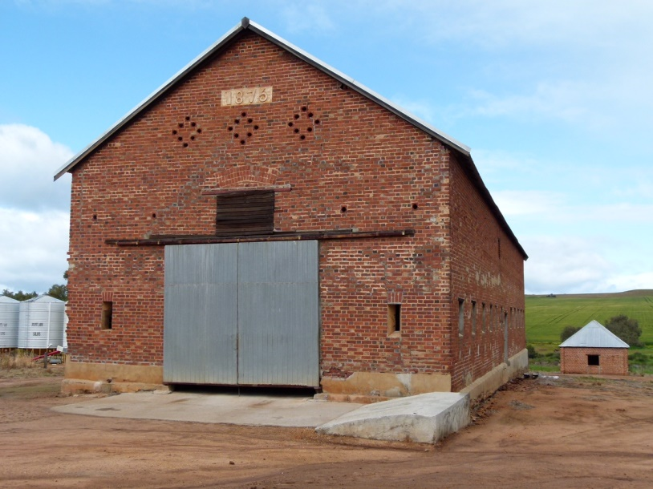
The buildings on Yangedine were large and numerous and would have required tens of thousands of bricks to be made and then laid on the property. Taylor initially employed brick workers in 1864 and 1866 before entrusting the hiring and supervision of the expirees to John McCarthy.
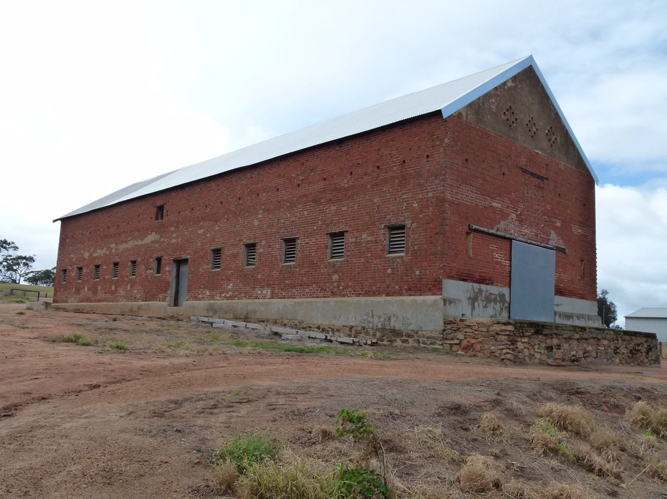
John McCarthy in turn employed up to eleven T.O.L. men in the years 1864-1876. Of the men recruited, only one was listed as a bricklayer on arrival in Fremantle. Other included Francis Harvey, previously a fishmonger, William Jones, a waterman, and James Ellis, a sailor. This suggests that most men continued to be taught and supervised by John McCarthy.
McCarthy also employed two Fenian expirees as labourers in York. These were Patrick Dunne in December 1868 and February 1869 and John Lynch in July 1869. Both were paid thirty shillings a week.
Another expiree who worked at Yangedine was Henry Duckham who had arrived in the Adelaide in 1855. He at least was a bricklayer by trade and later employed two experienced expirees to assist him at Yangedine in 1869 and 1872.
John and Mary McCarthy’s children remained in the York area. Mary Anne married Patrick Hackett in 1882 in York. Patrick was born in Vasse in 1857 and had farmed at Ludlow with his father before becoming a Police Constable stationed at York and then Beverley. Hackett was brutally murdered at Beverley in 1884 a week after his second child was born. His first child had died aged only two weeks. Mary McCarthy was at her daughter’s house at the time of the murder.
McCarthy’s son Charles married Catherine Toomey, daughter of William and Johanna Cahill, at York in 1876. Catherine had arrived on the Hamilla Mitchell with her parents in 1859. Charles and Johanna had a large family, with Charles following in his father’s trade as a bricklayer. One of their children, born in 1887, was named Patrick Joseph which was possibly in memory of his deceased uncle Patrick Hackett.
Mary lived with her widowed daughter in York until she died in May 1900. She was buried in York. John McCarthy died in 1904 aged seventy-two and was buried in York. Both lie in unmarked graves.
John McCarthy’s fine brickwork at Yangedine is reflected in the buildings that remain but sadly his contribution to many other public or private buildings in and around York is not known. He does nevertheless provide an example of a man who learnt new skills, overcame the stigma of having been a convict, and became highly regarded in the York community.

